Lady Arredondo Orozco
Professor Sina Nazifi Takan Tappeh
Introduction to Machine Learning 1371
17 May 2026
Movie Recommendation Final Project
In this project I had wanted to set up a basic movie recommendation machine learning project. I had wanted to do this to make a more general movie recommendation system. Now currently 61% of American households are watching 7.5 hours of content a week (Average). So many current systems like Netflix, Hulu, Prime are limited to their own library rather than all in choice. With all these services folks deal with oversaturation of options. I have spent many nights trying to pick a movie with my partner and just scrolling for hours. I know many other customers have the same issue. It not only goes into film, but tv shows, music, food anything where we must make a choice. Some researchers and companies like Netflix are currently using with working on DLRM’S (Deep learning-based recommender models) (Kabir) but their research remains mostly in-house with no visibility. Another study used CNN (Convolutional Neural Network) to help predict recommendations that study however was limited in their scope pulling data from the browser and only from 215 participants. My hope is that I can get a broad understanding of recommendation models and pull from a larger set.
The problem I’m trying to resolve is getting the Machine learning to provide accurate predictions of what someone would like based on their past self-reported ratings. Some of the inputs I am reviewing are genres, directors and reviews. My target is to see how accurately it can predict whether someone will enjoy a film based on their past choices. Initially this is a classification issue given that it must learn genres but later move onto a regression.
In this project I am pulling directly from a Kaggle dataset called “The Movies Dataset” The set has metadata for 45,000 movies separated in several csv’s. Some of the sets had datapoints like cast, crew, plot keywords, budget, revenue, posters, release dates etc. Most importantly the dataset has files containing 26 million ratings from 270,000 users for all 45,000 movies based on a scale of 1-5. When I reviewed the set initially, I checked the head and tail to get a better view of the two sets I was using. In my case I limited my focus on the movie metadata and the smaller version of the ratings. I also checked if there was any data missing by checking the nulls. Fortunately, it came up with no nulls. I also ran a command checking the main keywords it uses. I had used random forest and K-means for my model selection I choose random forest so that I could check multiple feature at one and I used K-means because it would help cluster related features. I imported tools like python, numpy, seaborn, pandas etc.
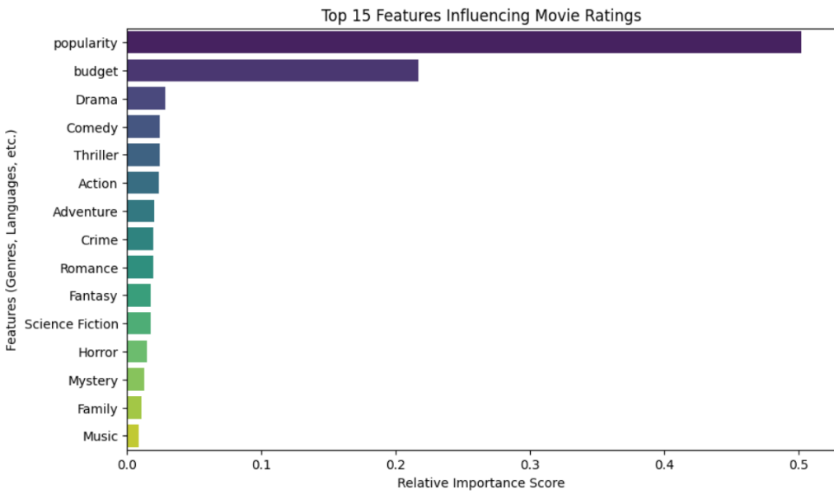
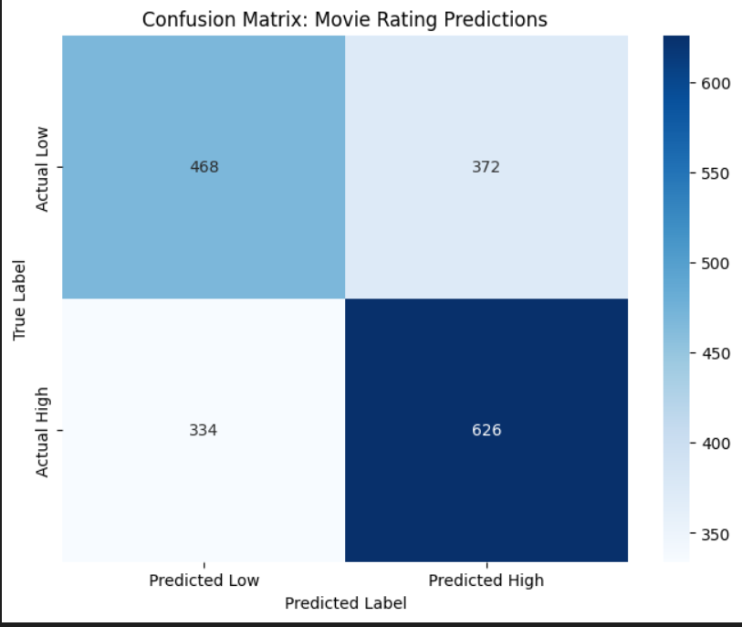
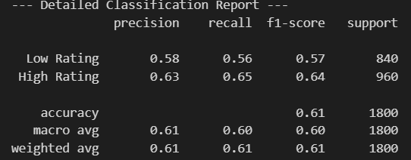
I initially had tried to run my model using a virtual environment and running it on a personal server which gave me lots of various errors about kernel installs and version numbers being too outdated. Which after testing various solutions I moved away from as to not cause further fiction on any future testers. I wanted to test features like vote average and popularity with random forest against the ratings which gave me a 60.78% accuracy score. I also encoded the various genres and language to also test and brought which ended with 60.72% accuracy. Which was less than what I had started with. I later tested another but with the column data encoded and retry the forest with budget, popularity with genres added in and that model ended with 60.72% accuracy. Still not a good overall measure still getting about 61% accuracy. I decided to see what features were impacting the model the most by running a feature importance chart listed in figure 1. The chart indicated that the popularity and budget of the film lent itself to a higher rating by users. To confirm these results, I also ran a confusion matrix to see impact shown in figure 2. It showed that True Positives (TP) was 626 when ML predicted High, it was actually high and True Negatives (TN) was 468 — predicted Low, actually low. Model also shows False Positives (FP) was 372 — predicted high, actually low False Negatives (FN) was 334 — predicted high, actually low. So far based on those parameters if a movie was popular and had a high budget it will likely get higher rating. Verifying with a classification report also yielded similar results.
Which is not the aim I was looking for, which was to predict an overall recommendation for a user.
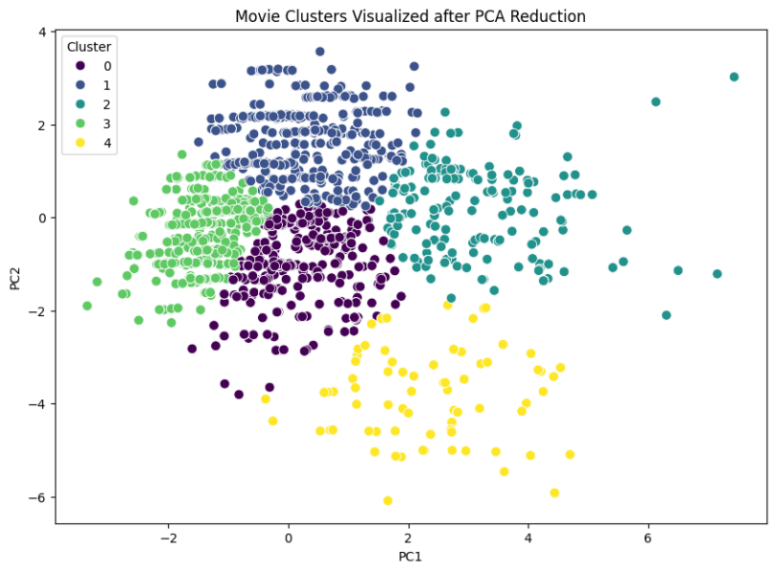
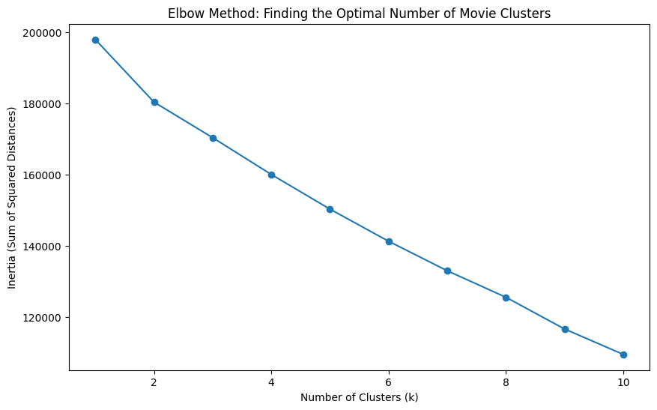
I decided to move on and try with K-means cluster to find any other insights. When I ran the code for that it was difficult to say where the elbow was since most of the adjustments were gradual but immediately it appeared that 3 or 4 were the closest based on figure 3. Since it was too close to tell I pulled in PCA reductions to help narrow the K means shown in figure 5. When I reviewed the cluster labels after adding them back in the grouping seemed a bit too broad. See figure 6.
Figure 4

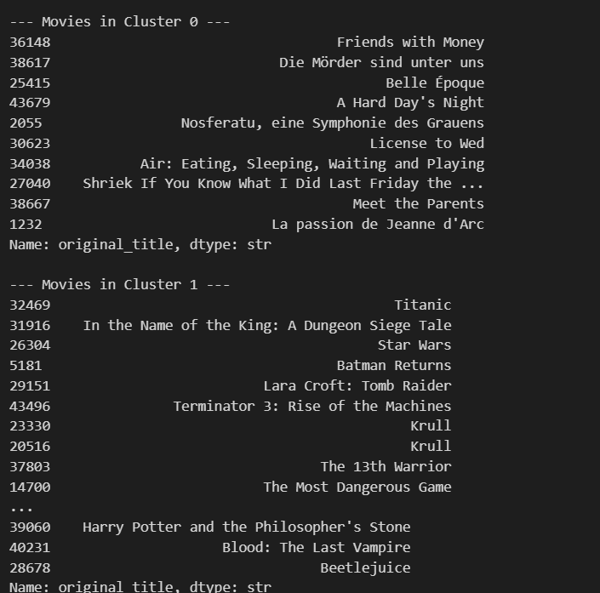
Lastly, I had retried with a new final cluster set. Trying with the most distinct ones ended with accuracy of 49% worse than I had begun with.
Overall, I saw how different features can really impact the model ie popularity and budget getting the highest ratings. Just because a film is popular and has money thrown at it does not mean that it’s the best for the user and on the other end K-Means can be flawed if the limit is set too low. Had I given it a larger parameter, it’s accuracy may have not been the same as a coin flip. In the future I plan to try out models to see where else things may be impacted, and how an actor or director can change a rating.

Citations
Average video viewing time rises to 43.5 hours per week in the US; do streamers need more phone-specific content?. Parks Associates. (2024, April 16). https://www.parksassociates.com/blogs/in-the-news/average-video-viewing-time-rises-to-435-hours-per-week-in-the-us-do-streamers-need-more-phone-specific-content
Gao, Y., Zheng, H., & Cui, H. (2025, May 13). User preference modeling for movie recommendations based on Deep Learning. Nature News. https://www.nature.com/articles/s41598-025-00030-5
Kabir , N., Liu, L., Delgado, P., & Padmanabhan, P. (n.d.). Netflix research. Netflix Research. https://research.netflix.com/publication/intune-reinforcement-learning-based-data-pipeline-optimization-for-deep

